**Progress Report: The Assigner Internship Test Assignment**

**Day 1: 11-11-2024**

**Task: Nav Bar and Hero Page**

**Status: Completed**

**Output:** 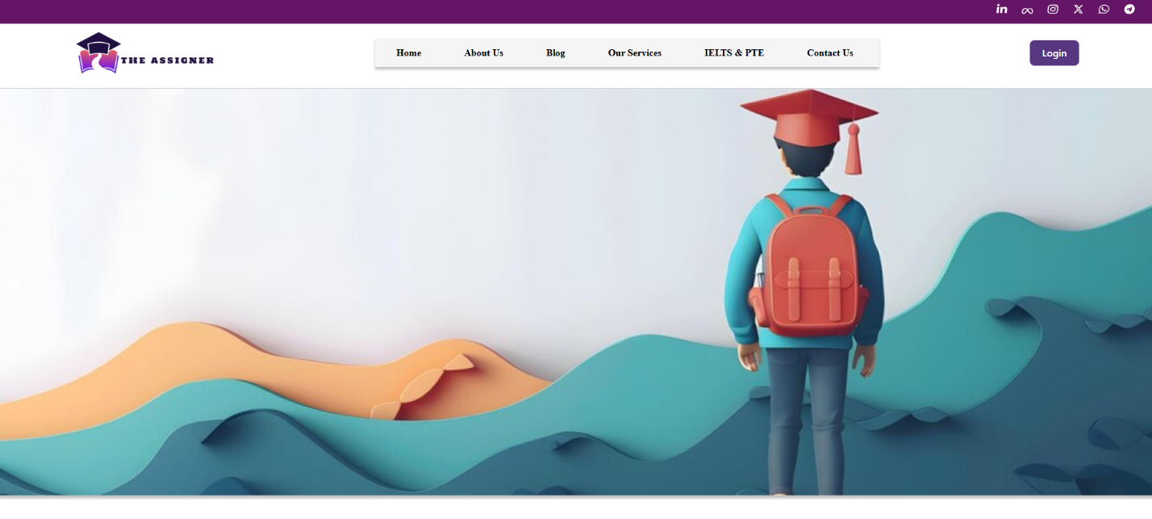

**Day 2: 12-11-2024**

**Task: Complete Page and Mobile version**

**Status:**

* Stats Page: Completed
* IELTS Preparation Page: Completed
* Awesome Features: Completed
* Our services: Completed
* Our Assistance’s advantages: Completed
* FAQ Icon designs: Pending
* Services Star Icon: Pending
* Footer Socials Links: Pending

**Output:**

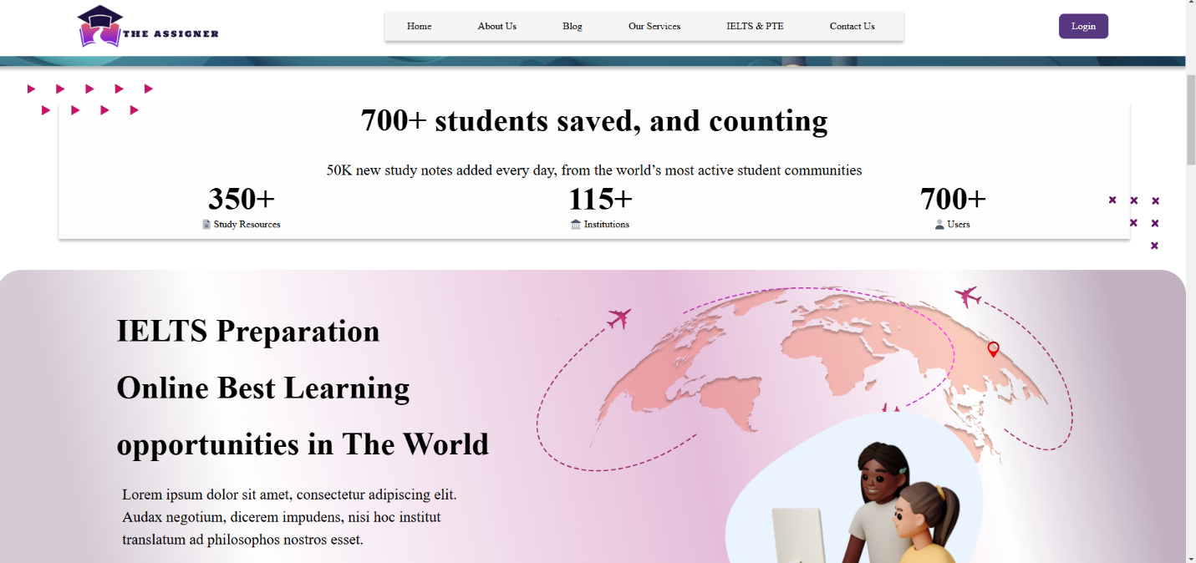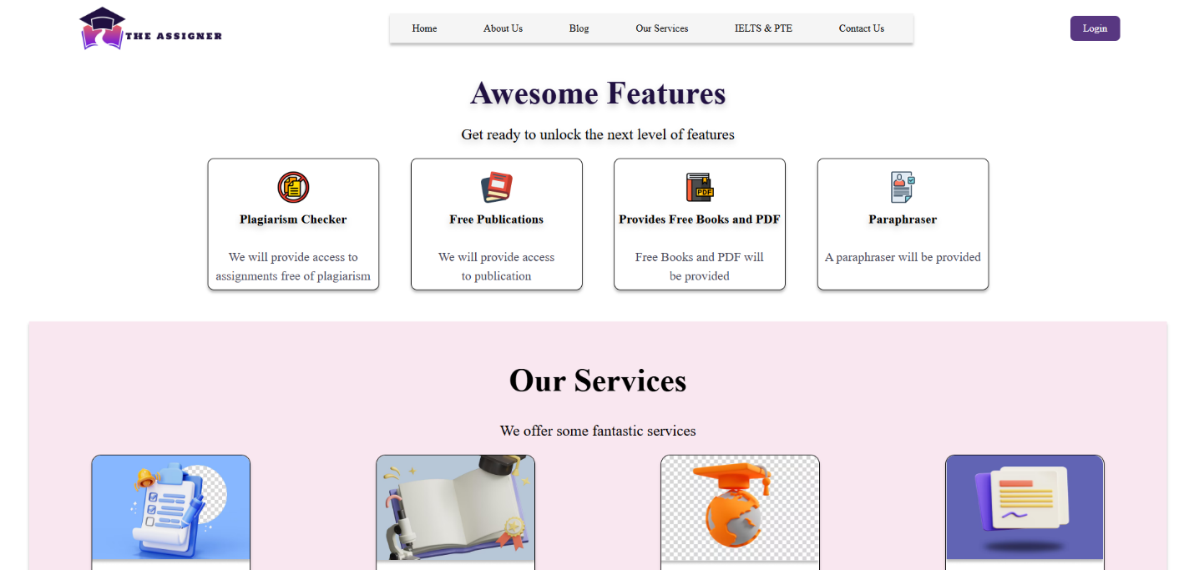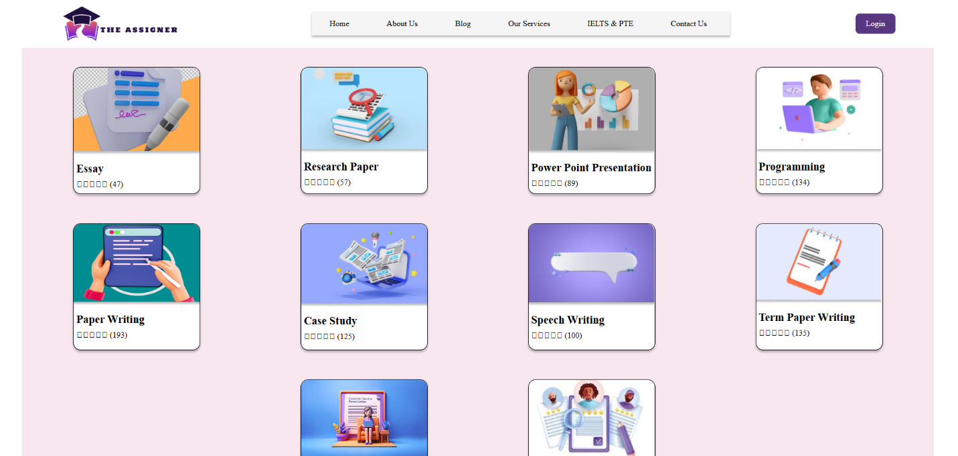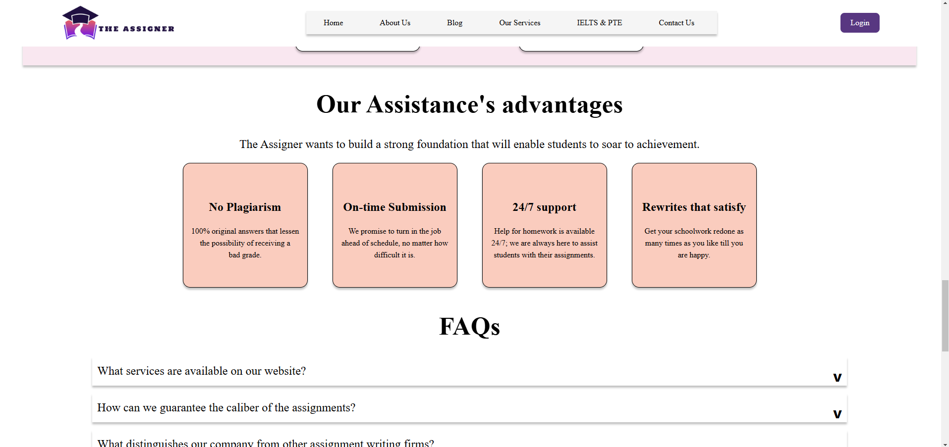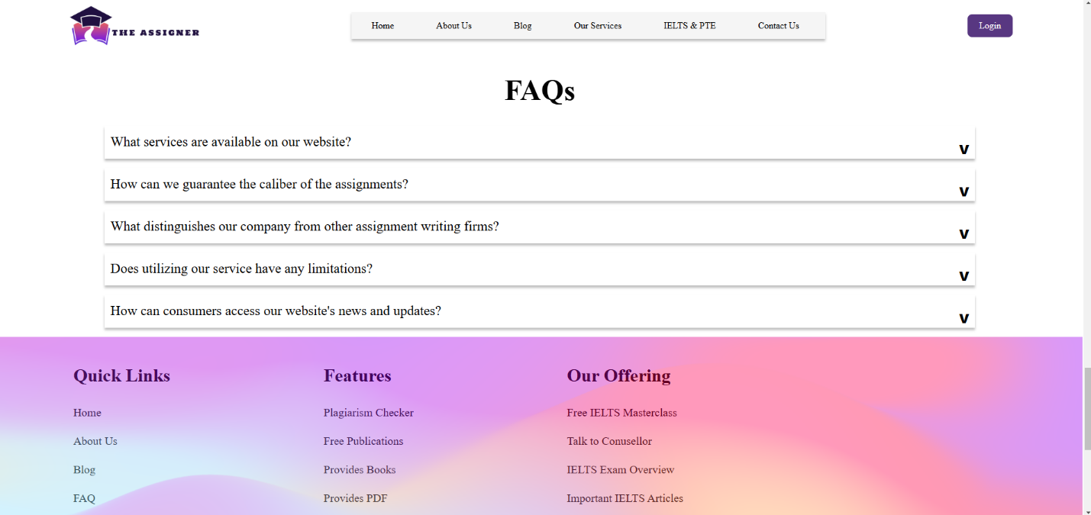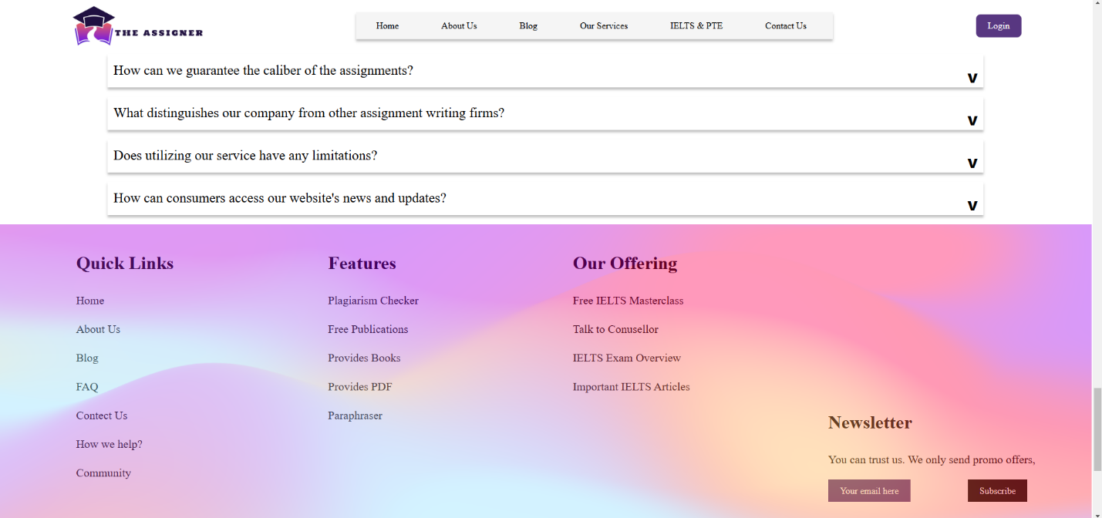

**Day 3: 13-11-2024**

**Task: Complete Page and Mobile version, Add a feature of choosing**

**Status:**

* Stats Page: Completed
* IELTS Preparation Page: Completed
* Awesome Features: Completed
* Our services: Completed
* Our Assistance’s advantages: Completed
* FAQ Icon designs: Completed
* Services Star Icon: Completed
* Footer Socials Link: Completed
* Responsive Design: Completed

Features Added:

* All buttons animated on hover
* All links animated on hover
* All cards (services, features, etc.) animated on hover
* Added Sidebar on mobile version to access hidden nav elements. (Animated)
* Faq Tabs show an answer when the arrow is clicked.

**Output:**

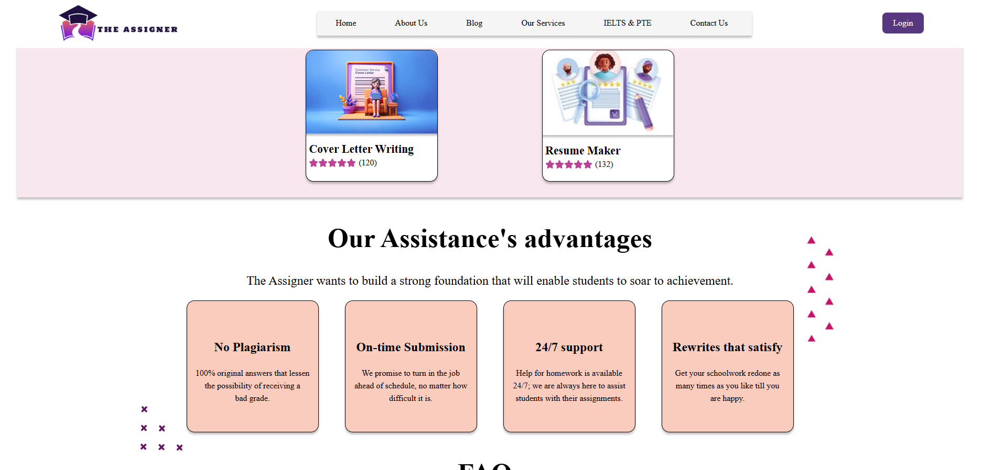

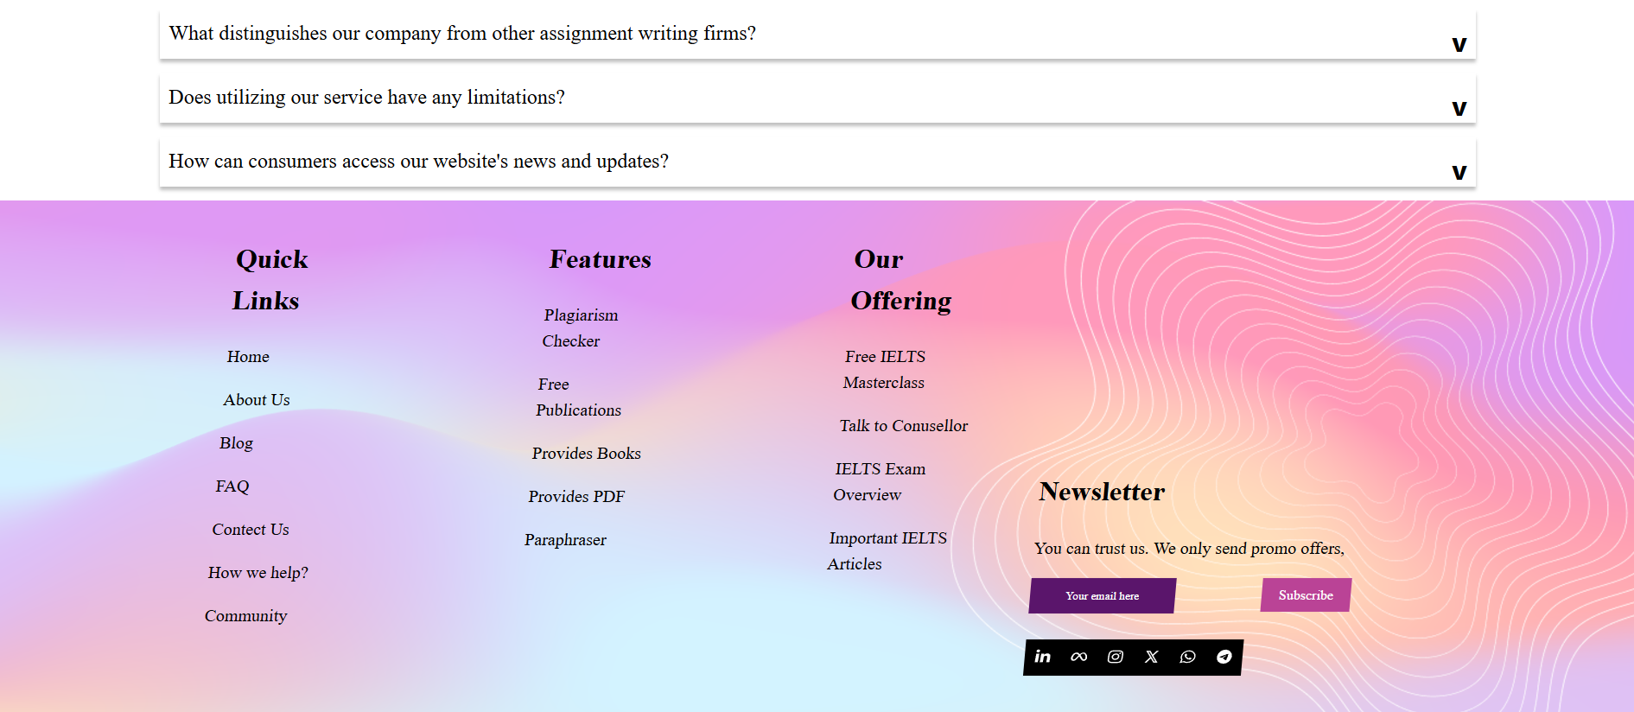

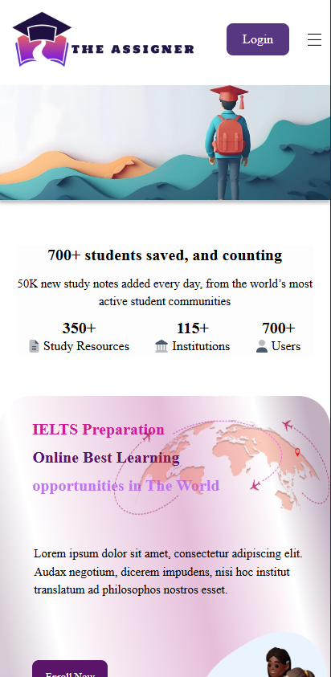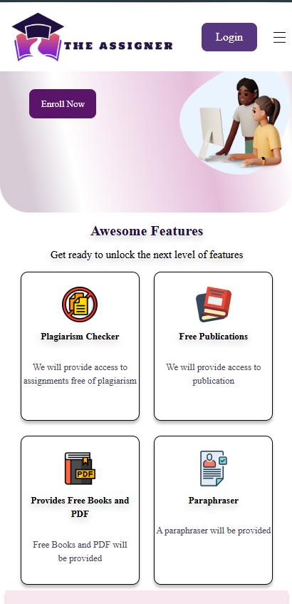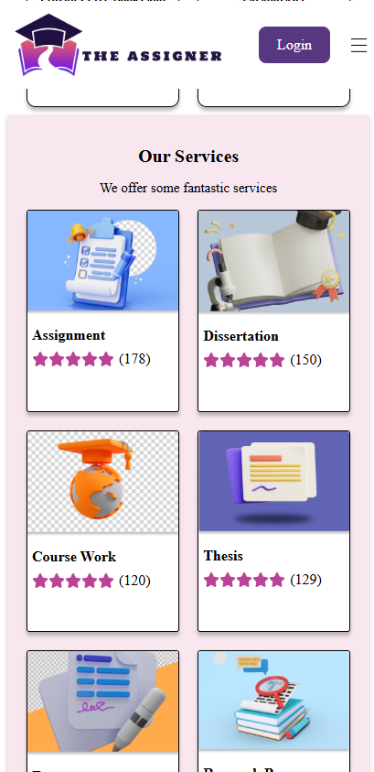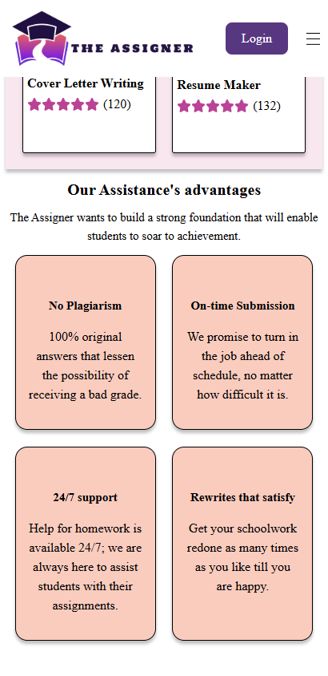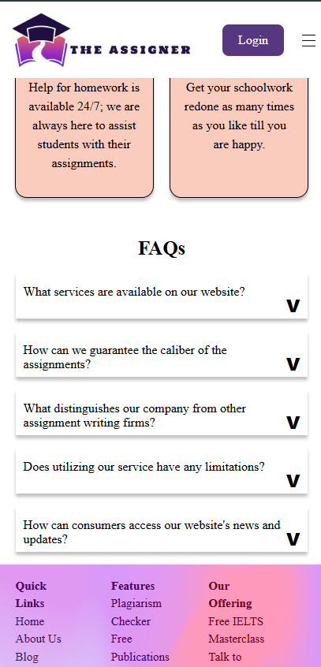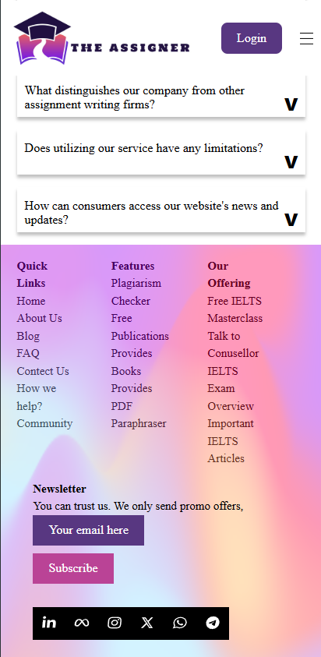

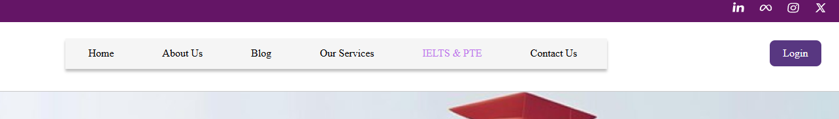

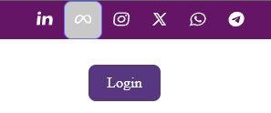

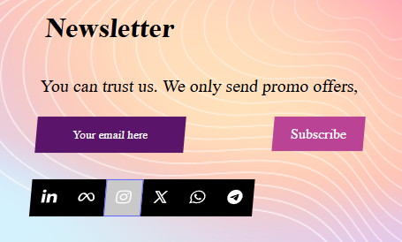

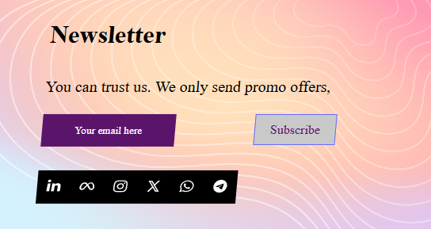

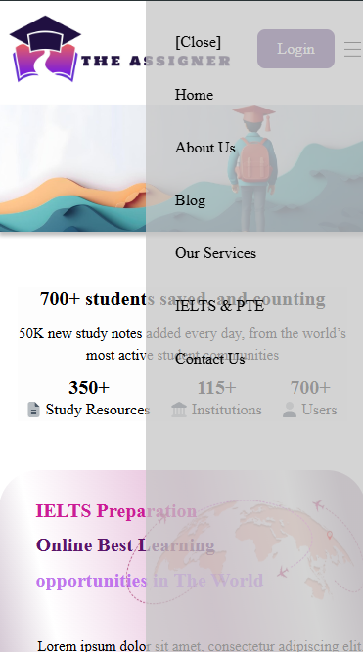

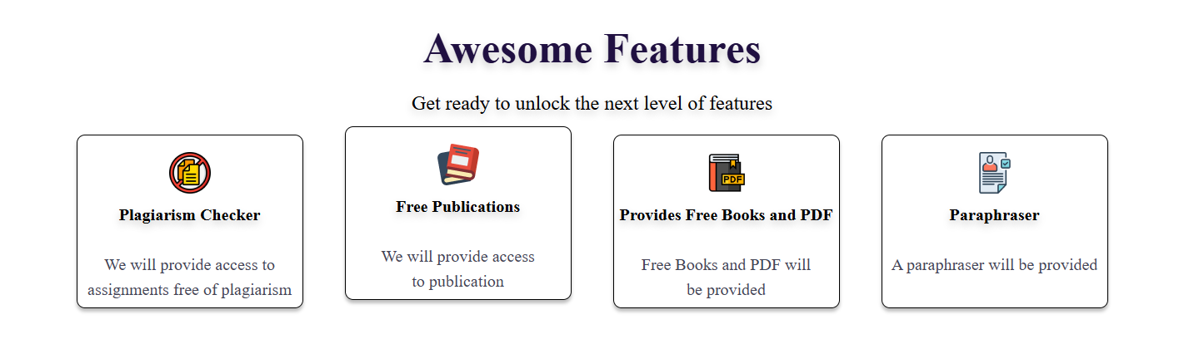

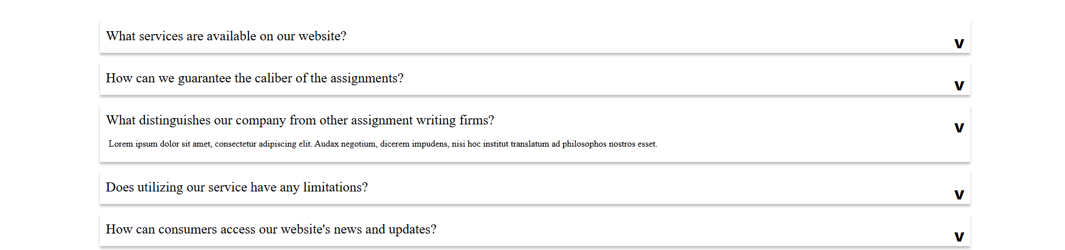

**Day 4: 14-11-2024**

**Task: Final Day**

**Features:**

* Added close Icon in Mobile-exclusive sidebar
* Made Page responsive for intermediate screens between 1600px and 600px width
* Added Image Carousel with translate animations. Left/right buttons and dot panel
* Added Email subscription form and a modal window for confirmation.

